# Executive Summary: Title of Final Report in Initial Capital Letters and No More Than Two Lines

Name 1, Name 2, Name 3, and Name 4

Team X.X, ME 340, Mechanical Engineering Department, Pennsylvania State University

This document presents a template for the summary of your design project. This summary should have no more than two pages of text―neither the space for illustrations nor the back matter (appendices and page of reference citations) is part of this total. This summary should present the most important details of the design project: the motivating problem; the customer needs and corresponding metrics; the generation, screening, and selection of a design concept; the prototypes; and the testing of the design. In this summary, because your team has not yet documented what your team learned from the series of prototypes or from the testing of the final design, please emphasize this information.

In the paragraphs before your first heading, summarize the problem that motivates your team’s design and introduce the design as a means of addressing that problem. If appropriate, summarize your customer needs and corresponding metrics. If discussing this information works better in a later section, you should place that discussion there. As a transition, conclude these introductory paragraphs with a mapping of the summary’s main sections.

## Concept Generation, Screening, and Selection (ME 297 Only)

In this first section, summarize the concept generation, screening, and selection. You might dedicate a paragraph to each perspective―for instance, one paragraph for concept generation. If appropriate, discuss your customer needs and functional decomposition here. Note that all headings should be 12 points, flush left, and boldfaced. The heading can be either a sans serif typeface (as was chosen for the title and the two headings here) or a serif typeface (as occurs in the text portion). However, the text must be a serif type, as shown here. Use initial capitals for the title and headings. Note that the template inserts a spacing of one skipped line before the heading and no line skips afterwards.

For both the title and section heading, use initial capitals as shown here. One convention, but not the only one, for using initial capitals is that you capitalize the first letter of the first and last words—no matter what the words. Then, you capitalize the first letter of every included word except for articles, conjunctions, and prepositions that have fewer than four letters: *a, an, and, as, but, for, in, nor, of, on, or, out, the, to, up,* and *yet*.

## Sequence of Prototypes

In the second section of this summary, discuss your sequence of prototypes. For instance, your team might have had an alpha 1 prototype, an alpha 2 prototype, and a beta prototype. This section should inform the reader what your team learned from each prototype and incorporated into the next stage of the design. For example, from one prototype to the next, it is important to discuss what design decisions were made, how those decisions were motivated by assessment of the previous prototype against design specifications, and how the design changes affected the specifications in question.

In this summary, you are encouraged to include illustrations. One important illustration would be the sequence of prototypes, your team might consider positioning those prototypes in a row of images such as in Figure 2: zeroeth prototype (left), alpha 1 prototype (center), and alpha 2 prototype (right). If you do so, then have your caption indicate which is the left image, the center image, and the image on the right. Also note that the illustration should occur after the introducing paragraph has finished. You should *not* break paragraphs in a Microsoft Word document to insert an illustration. However, if your illustration is narrow with significant white space on either side, you have the option to select the figure, and then select “In Line with Text” in the “Wrap Text” menu of the “Picture Tools Format” tab that appears in the menu bar.

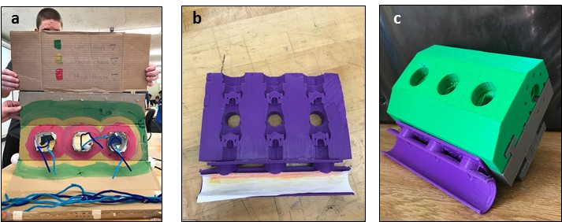

**Figure 1**. Sequence of prototypes for the model of the Clean Fleet Pumps: (a) zeroeth prototype,   
(b) alpha 1 prototype, and (c) alpha 2 prototype.

## Performance of Final Design

In the third section of this summary, you should discuss the performance of your final design. In particular, you should discuss how well the design meets the metrics introduced earlier in the report. In this section, you should have an illustration, such as Figure 2, of your final design. When introducing an illustration, do not use pointers such as *below* or *on the next page*. Your technical reader knows where the illustration is supposed to be placed—after the paragraph that introduces it or on the next page if not enough space exists below the paragraph. As such, saying “below” or “on the next page” is redundant and makes for needless work on drafts.

In addition to writing this summary, your team is to include three appendices. One appendix (Appendix A) should discuss what the team would do differently, if given the chance to go through the design process again. A second appendix (Appendix B) would discuss how your client is to use the final design. Yet a third appendix should describe relevant calculations that you refer to in this summary. For instance, one possible calculation would be for the nominal operating point of the wind turbine. Please remember that you should all appendices by name before they appear. For that reason, include a sentence or a parenthetical in this summary that formally introduces each of those appendices. Included in this template is a description of the appendix for changes to your design process (Appendix A). Also included is a description of the appendix that provides instructions on using the wind turbine (Appendix B). Finally, described in Appendix C are possible calculations or principles for you to include.

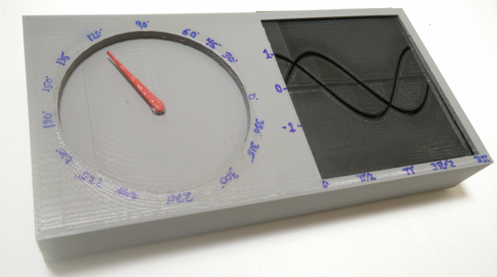

**Figure 2**. The 3D-printed beta prototype of the Trig Unit, which incorporates key design improvements from the alpha prototypes to better satisfy the customer needs [1].

After the appendices, include a separate page with reference citations. These reference citations at the end should arise from reference listings in the text. For reference listings in the text, please follow the IEEE [#] format, which calls for numbers placed in brackets. Note that every reference listing in the text corresponds to a reference citation at the end. Likewise, every citation at the end has at least one reference listing in the document. In the references section at the end of the document, you will find sample citations for a book [2], a journal article [3], a company brochure [4], a presentation [5], a company report [6], a patent [7], or a website [8]. For those in ME 297, this summary will be evaluated not only for structure, illustration, and form, but also for language.

### Appendix A: How the Design Could Have Been Improved

This appendix presents a reflection on what you would have done differently in the design process to come up with a stronger design. Please use this appendix to reflect how a future design team in ME 340 could improve upon the model that you just designed. Put another way, if your team had the opportunity to do the same design project again, what would your team design in the same way and what would your team design differently? In putting together this appendix, please consider including the results of your Design for Manufacturing and Assembly (DFMA) and Design for Additive Manufacturing (DFAM). Limit this appendix to no more than two pages (including illustrations).

Each appendix is to begin on a separate page. Titles of appendices are 14 points, flush left, and boldfaced. Use initial capitals. Finally, illustrations in this appendix are labeled Figure A-1, Figure A-2, Table A-1, Table A-2, and so forth.

## Sample Heading 1

In writing this appendix, you might consider having two or perhaps three subheadings. Note that if you choose to have one subheading, you must have a second. Otherwise, the first one has nothing with which to be parallel.

## Sample Heading 2

In our format, all headings should be 12 points, flush left, and boldfaced. The heading can be either a sans serif typeface (as shown here for the title and the two headings) or a serif typeface (as occurs in the text portion). However, the text must be a serif type, as shown here. Use initial capitals for the title and headings. Note that this template’s format calls for a spacing of one skipped line before the heading and no line skips afterwards.

### Appendix B: How to Use the Wind Turbine (or Discovery Space Exhibit)

An appendix, which occurs in the back matter of a report, provides either secondary information for the primary audience or primary information for a secondary audience. Authors place such information into an appendix so that it does not take away emphasis from the main “story” of the report. This appendix presents a set of instructions for customers on how to use your team’s wind turbine (or exhibit for the Discovery Space section). Our suggestion is that you have one paragraph to introduce the instructions. This paragraph should be followed by three or four steps that explain how to use the wind turbine (or exhibit). Please avoid having more than four steps in a single sequence because long lists of steps intimidate readers. Limit this appendix to no more than two pages (including illustrations).

1. *Place the first step of the instructions in italics.* Follow that command with normal text that explains the step. To support these steps, you should include at least one illustration, such as assembly of a design model in Figure B-1. Note that if the centered illustration does not span the margin, you can have the margins of the caption narrowed as well.

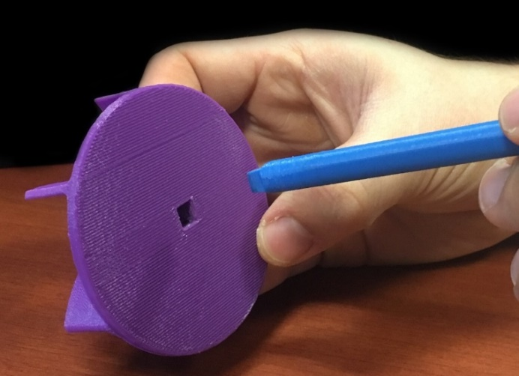  
**Figure B-1.** Connection of purple impeller and blue shaft [9].

1. *Place the second step of the instructions in italics.* Because this appendix is set of instructions, please feel free to use the pronoun *you.* Note, though, that while the pronoun *you* is appropriate for instructional texts, it is not appropriate in technical writing for texts that document a project or design. For a second illustration, see Figure B-2.
2. *Place the third step of the instructions in italics.* In general, the style for instructions differs significantly from the styles of proposals and reports, because the emphasis for the reader of a set of instructions is on the *how,* often without regard for the *why*. For that reason, the style of instructions includes vertical lists, use of the pronoun *you,* and occasional sentences written as commands. Also, be generous with illustrations, perhaps including an illustration with each step. For a third illustration, see Figure B-3.



**Figure B-2.** Pump shaft and volute [9]: feeding of pump shaft through the volute piece (left); assembly with second volute piece (right).

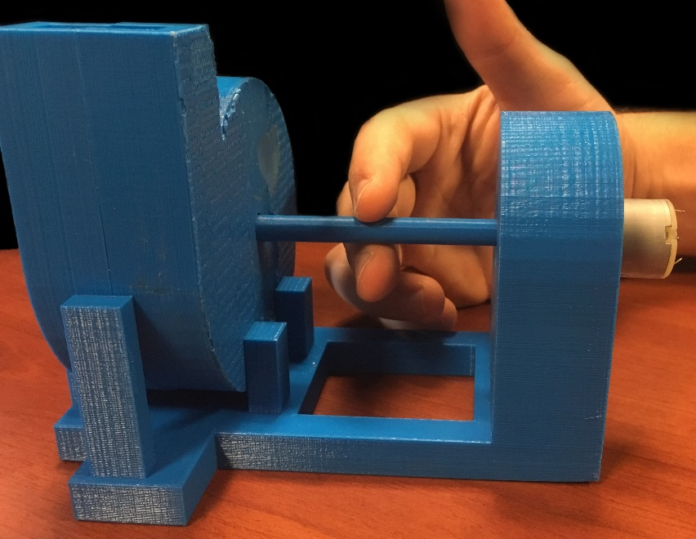

**Figure B-3.** Fully assembled system, which you can now connect to electrical power to turn the shaft [9]. Note that you can also use your hand to rotate the shaft, as is shown here.

After your list of steps, include a paragraph that provides closure to the set of instructions. Each appendix is to begin on a separate page. Titles of appendices are 14 points, flush left, and boldfaced. Use initial capitals. To preserve hierarchy, allot more vertical space before the appendix title than after it, as is incorporated here. Finally, be sure that you have introduced this appendix somewhere in the text of the report.

### Appendix C: Physical Principles to Make Design Choices

This appendix presents physical principles for making your design choices. For the wind turbine project, the section should focus on how the power generation of the final concept compared with what is theoretically calculated. To do so, you should make use of wind velocity measurements and target angular velocities to determine one of the following: (1) nominal operating point (for the desired power output) or (2) optimal angle of attack (blade pitch for desired power output). For the Discovery Space section, this appendix would be the use of physical principles to make the choices in the design process. For both types of design projects, please limit this appendix to no more than two pages (including illustrations).

Each appendix is to begin on a separate page. Titles of appendices are 14 points, flush left, and boldfaced. Use initial capitals. Finally, illustrations in this appendix are labeled as follows: Figure C-1, Figure C-2, Table C-1, Table C-2, and so forth.

## Sample Heading 1

In writing this appendix, you might consider having two or perhaps three headings. Note that if you choose to have one heading, you must have a second. Otherwise, the first one has nothing with which to be parallel.

## Sample Heading 2

In our format, all headings should be 12 points, flush left, and boldfaced. The heading can be either a sans serif typeface (as was chosen for the title and the two headings here) or a serif typeface (as occurs in the text portion). However, the text must be a serif type, as shown here. Use initial capitals for the title and headings. Note that the template inserts a spacing of one skipped line before the heading and no line skips afterwards.

## **References**

|  |  |  |
| --- | --- | --- |
| [1] |  | J. Cavanaugh, A. Cutrell and P. Shushari, "Executive Summary: Trig Unit Design Process to Engage Introductory Calculus Students," Pennsylvania State University, University Park, 2016. |
| [2] |  | Y. Cengel and M. Boles, *Thermodynamics: An Engineering Approach,* New York: McGraw-Hill, 2014. |
| [3] |  | R. A. Perry and D. L. Siebers, "Rapid Reduction of Nitrogen Oxides from Diesel Exhaust Engines," *Nature,* vol. 324, no. 2, pp. 657-659, August 1986. |
| [4] |  | D. Cheng, Chemtronix XT Manometer [brochure], Asheville, N.C.: Chemtronix Corporation, 1974. |
| [5] |  | J. Frank, The Industrial Internet of Things: Predictive Maintenance in Advanced Manufacturing [presentation], University Park, PA: ME 340, Penn State, 2016. |
| [6] |  | IBM, *Guide to Operations,* Boca Raton, Florida: IBM Personal Computer Hardware Reference Library, 1984. |
| [7] |  | R. K. Lyon.United States of America Patent 3,900,554, August 1975. |
| [8] |  | J. Mockery, "Cross-Section of a single stage radial centrifugal pump," May 2007. [Online]. Available: http://hu.wikipedia.org/wiki/F%C3%A1jl:CetriFugal_Pump.jpg. [Accessed October 2016]. |
| [9] |  | J. Smith, T. Nocera, P. Norouzi and R. Lynam, "Final Report on the Functioning Model of the Centrifugal Pump Designed for KCF Technologies," ME 340, Mechanical Engineering Department, Penn State, University Park, PA, 2016. |