Title of Wind Turbine Proposal
in Initial Capital Letters

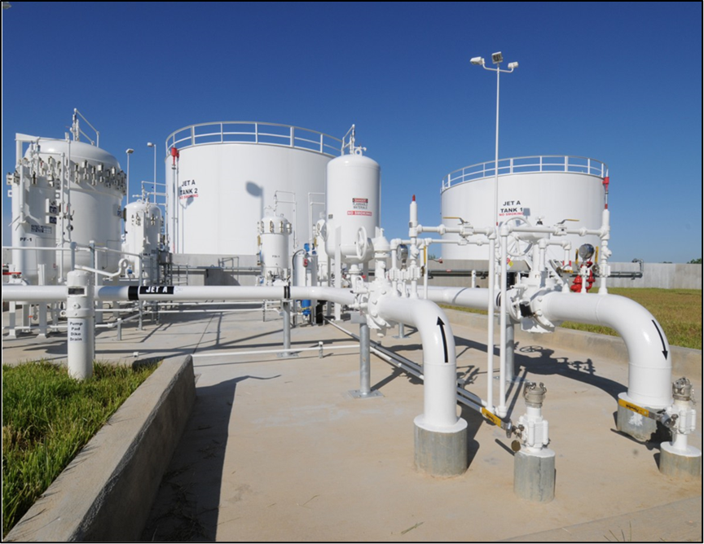
Pond & Company [1]

Name of Author 1

Name of Author 2

Name of Author 3

Name of Author 4
ME 340, Spring 2018
Mechanical Engineering Department
Pennsylvania State University
XX March 2018

Title of Wind Turbine Proposal
in Initial Capital Letters

Name of Author 1

Name of Author 2

Name of Author 3

Name of Author 4
ME 340, Spring 2018
Mechanical Engineering Department
Pennsylvania State University
XX March 2018

Summary
This document presents the format (the typography and layout) that you are to follow for the wind turbine proposal in ME 340. Because no universal format exists for engineering reports, each institution specifies a format that engineers are to follow. Our course does the same and has selected the format of a large engineering research laboratory: Sandia National Laboratories [2].
On this title page of the proposal, your team is to present a two- to three-paragraph summary of the most important details of the proposal. One major detail is the problem, which centers on the small-scale wind turbine that your team has been asked to design those in need and without access to an electric grid. Another major detail is your team’s proposed design. The summary should capture the most important ideas from the three main sections of this proposal: (1) Statement of Problem, (2) Proposed Design for Wind Turbine, and (3) Management Plan. Because the summary repeats the most important details of the proposal, the summary should include the following about the proposed design concept: choice of turbine, blade design, stand design, power transmission design, efficiency calculation, and electrical power output. Please note that every detail that occurs in this summary should appear in at least that much detail in the main text of the proposal.
The format of this proposal requires that the summary is to fit within this single title page. Also required are that you indent all paragraphs in this document and use a serif typeface such as Times New Roman (12 points) for the text portions. However, for the title, the headings, and subheadings, a bold sans serif typeface such as Calibri is fine to use. The line spacing for this paragraph is to be single-spaced at 1.15 spacing. Also, as in common in books and formal reports, please do not skip lines between paragraphs. For the title and section headings, you are to use initial capitals as shown above. Finally, note that every team’s proposal will be evaluated for content, illustration, and form (the stated guidelines for format and the rules of grammar, punctuation, and usage).

Contents

Summary ii

Statement of Problem 1

Proposed Design for Wind Turbine 2
Prototype Needs and Accompanying Metrics and Specifications 3
Function Structure and System Decomposition 4
Concept Generation 5
Concept Screening and Selection 5

Management Plan 7

Appendix A: AHP Matrix 8

Appendix B: Incorporating References 9

References 11

Statement of Problem
This section discusses the problem that motivates the need for a design of a small wind turbine that will provide power for those without access to an electrical grid. This section not only establishes that your team has been tasked with designing a small-scale wind turbine, but also describes an example need and application for such a turbine. In describing the need and application, the section makes and defends the following three assertions to the audience:
- a need exists such as lack of lighting in homes of a developing country;
- a small amount of power, such as 0.5−1 watts, could run a device to address that need; and
- the wind in the region will be sufficient to power the turbine.
In this section, you should have a formal description of the problem, even though you did so in the summary. In engineering writing, you should not fear repetition of important details. Such repetition is important for emphasis. In fact, in a technical report, every idea in a summary should appear in at least that much detail in the main text of the document. Also, the description of the project in this section is more detailed than the description in the summary. Note that even though your main audience might already understand the problem that motivates the project, you should still explain that problem. One reason is to allow the proposal to be understood by a wider audience: people in the region, engineers looking to use wind turbine in a similar situation, a job recruiter who has asked to see a sample of your writing, or mechanical engineering students taking this course next semester. Another reason is to show that you understand the problem.
In addition to showing that a need exists, you should formally state that your team has been tasked with designing a small-scale wind turbine as a means to address that problem. To support the contention that a wind turbine could address the need, you should include background information on how much power an application would need and the wind conditions in the region. At this point, you probably have realized that the assertions made in this section are similar to the assertions that you made in the initial research presentation and handout. For that reason, you will want to use your initial research (and the references) to build your argument here.
In this section, you are encouraged to include illustrations. Possibilities include a photograph that depicts the need or a table showing the wind conditions in the region. Please note that each illustration should be introduced by its formal name (Figure 1, Table 1, and so forth) in the report before the illustration appear. As an example, please consider Figure 1, which shows a photograph from a previous year’s design proposal—in this case, a pump station for transporting airplane fuel to an airport. In introducing an illustration, do not use pointers such as “below” or “on the next page.” Such tags are not only unnecessary, but also unwanted. Moreover, note that putting labels in figures can be an effective way to emphasize the most important details. Finally, make sure that the figure caption describes what the reader should see. As is common in reports, the caption for Figure 1 consists of a defining phrase, which is often followed by a sentence that explains unusual details.

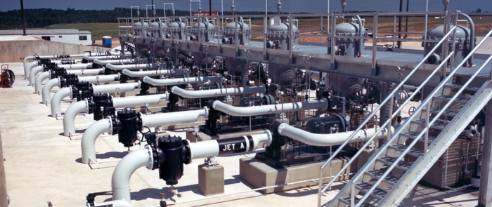
Figure 1. Pump station that uses vertical pumps to transport jet fuel from underground storage tanks to the airport [3]. Much is expected from these pumps because the storage tanks are often 1 mile from the places where the planes are refueled.
In the format of this proposal, note that all major headings, including the “Statement of Problem,” are 14-point font, flush left, and boldfaced. Use initial capitals for the heading title. To preserve hierarchy, insert more vertical space before the heading than after it, as shown in this template. In this document, please indent all paragraphs and do not insert a line skip between paragraphs within the same section. In addition, use a serif typeface such as Times New Roman (12 points) for the text portions of the document. While a sans serif typeface such as Calibri is appropriate for headings and the call-outs of illustrations, sans serif type is not recommended for large blocks of text. The line spacing for this paragraph is to be single-spaced at 1.15 spacing, which is common in professional documents. For the title and section heading, use initial capitals as shown in the section heading above. An explanation of initial capitals occurs on the report format page of the website Writing Guidelines in Engineering and Science [4].

Proposed Design for Small Wind Turbine
At the beginning of this second major section of the proposal, you should explicitly state the pitch of your proposal: “This document presents a proposed design of a small wind turbine to provide low power (on the order of 0.5 watts) to ________.” Note that what you place in the blank should be broader than the specific application in the previous section. In addition to making the proposal’s pitch, this section should state your assumptions and limitations for this proposed design. For instance, one limitation might be the type of electrical generator that your team will use to provide electrical power. Another might be the cost restriction imposed on the design. Yet a third might be the means for testing the design.
To make a smooth transition to the four subsections of the proposed solution, you should map those subsections. Note that different sentence openers exist for these sentences other than the standard “The next subsection presents….” For instance, you could begin with “Given next is the function structure and system decomposition of a small-scale wind turbine.” Because the subsections exist for the reader, the preferred tense for these sentences is present tense (“The next subsection presents….”), rather than future tense.
Prototype Needs and Accompanying Metrics and Specifications
This subsection presents a discussion of the prototype needs and the accompanying metrics and specifications. So that the reader knows where those prototype needs arose, you should state their origin: “For this project, three prototype needs were specified.” Even though the project specified the three prototype needs for your team, this subsection should explain those needs. In addition, the subsection should explain your choices for the accompanying metrics and target specifications. To emphasize the needs, metrics, and specifications, you are required to include an illustration, such as Table 1. As given in that example, the matrix should relate the prototype needs to specific metrics (measurable quantities) and underneath give target (and minimally acceptable) values. As stated earlier, each illustration should be introduced by name before it appears in the text. Note that you should not interrupt a paragraph to insert an illustration.

Table 1. Customer needs and accompanying metrics and specifications for cardboard chair.
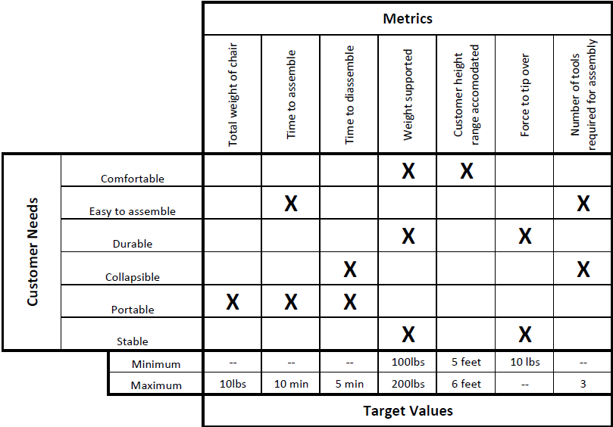

Please note that that because a subsection has a lower level of importance than a section, the subheading is distinctly smaller than a heading. In our format, the subheading should be 12 points and boldfaced. As with a heading, more vertical space precedes a subheading than follows it. As with a heading, you should use initial capitals for a subheading. Finally, the first sentence should orient the audience to contents of the subsection.
Function Structure and System Decomposition
This subsection presents a discussion of the function structure and system decomposition that your team performed on your device. Here, you present the functional structure and system decomposition of the wind turbine’s systems and subsystems. Most likely, you will want to include a figure, such as Figure 2, to show how the device operates. To distinguish the typography of the figure caption from the typography of text, you should place the figure caption in a smaller typeface, as was done in Figure 2 (in this case, 10 points). For the caption, a nice formatting touch is to place the name of the figure (or table) in boldface and have the text of the figure caption (or table heading) in the normal text.

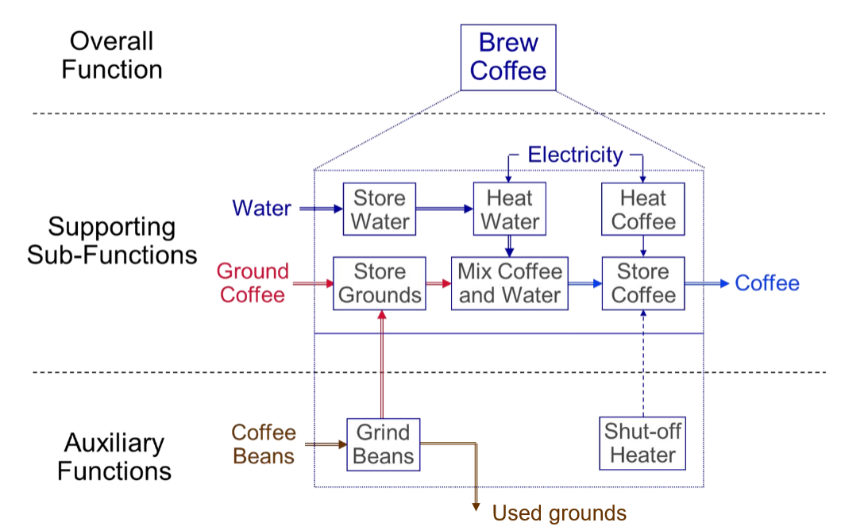
Figure 2. System decomposition of a coffee-maker [14]. By looking at the energy, material, and signal flows going into and out of a sub-function, we learn what is needed to design this sub-function and with what resources we have to work with. For instance, for the sub-function “heat water,” inputs would be water (material), electricity (energy), and on-off switch (signal). The outputs would be hot water (material), heat (energy), and on-off switch (signal). In your report, you will want to include a specific decomposition of your team’s wind turbine.
In this section, you show your insights into the system and its subsystems. As stated before, subheadings should be 12 points and boldfaced. Also, the amount of vertical space before and after this subheading should be the same as occurred for the previous subheading. For the subheading, you should use initial capitals.
In writing this proposal, you should support your claims with statistics from reference sources. For reference listings in the text, please follow the IEEE [#] format, which is incorporated in this template. In engineering and science, we typically use brackets for reference listings because we use parentheses in so many other ways. Note that every reference listing in the text corresponds to a reference citation at the end. Likewise, every citation at the end has at least one reference listing in the document. In the references section at the end of the document, you will find sample citations for a book [5], a journal article [6], a company brochure [7], a presentation [8], a company report [9], a patent [10], an interview [11], a website [12], and a newspaper article [13]. Refer to Appendix B for additional instructions on inserting references.
Concept Generation
This subsection introduces the list of concepts that your team considered for your wind turbine design. This list should arise from the system decomposition discussed in the previous section. Included in this discussion are your team’s methods for generating this list of subsystems and your multiple concepts generated for each subsystem. Note that your team could list the same subsystem as two different concepts, if one of the concepts included a different feature. Required for this section is a table (or figure) listing the different concepts.
Because you are writing as an engineer, the style of the writing is significantly different from the writing style of other disciplines such as creative writing. For example, in engineering and scientific writing, avoiding ambiguity is critical. For that reason, many scientific editors recommend not using the word this as a standalone pronoun, but using this word to point to a noun or noun phrase: “this device” or “this vibration at resonance.” In addition, unlike poets, when engineers and scientists want the meaning of “because,” they use the word because, rather than the word as. The reason is that the word because has only one meaning, while the word as carries other meanings such as “while.” As a third example of this difference between scientific writing and creative writing, engineers and scientists place a comma after an introductory clause, phrase, or transition word (the word however, for example) so that the reader can see where the introductory part of the sentence ends and the main part of the sentence begins. As a fourth and final example, engineers and scientists do not use contractions, such as isn’t, because contractions are simply considered too informal for formal documents in engineering and science. More explanation about these differences can be found in The Craft of Scientific Writing [15]. Four copies of the book are on two-hour reserve in the Engineering Library of Penn State.
Concept Screening and Selection
This subsection makes an argument for your team’s selection of a turbine design: choice of turbine, blade design, stand design, power transmission design, and efficiency calculation. Required for this argument are tables for the concept screening and concept scoring. Appearing in Table 2 is an example of a concept scoring matrix. In this subsection, you are also required to include your efficiency calculations.
Table 2. Example of a concept scoring matrix that will occur in the design proposal [16].
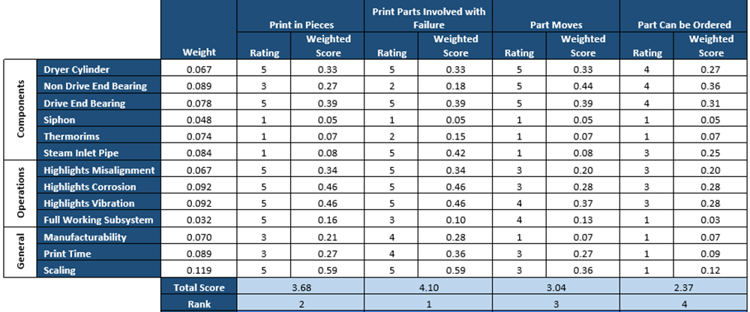

In this subsection, your team should connect the lists of selection criteria back to the prototype needs and accompanying metrics. To this end, your team should mention how your AHP matrix, which is presented in Appendix A, determines the weightings of these criteria. For some designs, you might have different tables to represent the different concept screening matrices and concept scoring matrices of the choices for blades, transmission systems, and stands. If so, your team is welcome to use sub-subsections. Not listed in the Table of Contents, these sub-subsections should have a format that reveals less hierarchy than the subsection. Given below are two sub-subsections: one for tables and one for equations. In your proposal, your sub-subsections might be as follows: Blade Design, Transmission Design, Stand Design, and Overall Design. In that last sub-subsection, you would include the required efficiency calculation.

Tables. Tables are rows and columns arrangement of words and numbers. As was shown in Table 2, tables are formatted in a fashion that is different from figures. Unlike figure captions, which follow the figure and may include an additional sentence or two, a table heading is a single phrase. In addition, the heading for the table precedes the table and is 12 points. If unusual details exist in the table, those are explained in footnotes beneath the table. Finally, please make sure that all figures and tables are numbered and labelled in the text and that they are referenced during your writing. This convention also means that you should explain each figure or table in the text to make sure that the reader knows what to look for when reviewing that figure or table.

Equations. To incorporate an equation, such as for an efficiency calculation, center and set apart equations from the text with white space. Using Arabic numerals, number those equations that are referred to in the text. For example, in the wind turbine project, the torque supplied by the rotor, T_{rotor_S}, is defined in equation 1:
$T{}_{rotor_S}= \frac{1}{2}C_{m}ρARU^{2}$ (1)
where C_{m} is the rotor-torque coefficient, ρ is the air density, A is the rotor’s cross-sectional area, R is the radius of the rotor, and U is the air velocity. When referring to equations, call them by their names: equation 1, equation 2, and so on. Also, when incorporating an equation, treat the equation as part of a sentence in the paragraph. For instance, in the wind turbine project, important calculations concern the power output to the application, P_{app}. One such calculation is for the torque needed for P_{app}. This torque, T_{rotor_N}, is defined in equation 2:
$T_{rotor_N}=\frac{P_{app}}{{ω_{rotor}}_{gen}}$ (2)
where ω_{rotor} is the angular velocity of the rotor, and η_{gen} is the efficiency of the generator. Notice that you define the dependent variable before the equation appears and you define any new independent variables beneath the equation. Once you have defined those variables once in the proposal, you need not define them again. Finally, do not let Microsoft capitalize the word where in the part of the sentence beneath the equation.

Management Plan
In your third and final major section of the proposal, please create a management plan in which you discuss the costs and schedule for your project. To explain your schedule, you are required to include a Gantt chart with tasks assigned to individuals and given a duration. Please note that a Gantt chart is formatted as a figure, rather than a table. In addition, briefly make a case for why your team is qualified to do this project. This section will conclude the proposal. Note that unlike a final report, a proposal often does not have a Conclusions section.
The three sections Statement of Problem, Proposed Solution, and Management Plan constitute the main text of this proposal. For this proposal, you should aim to keep your main text to no longer than 10 pages—this page length includes illustrations. However, if your length goes longer, you will not receive a penalty. Rather, we give you this target length to help you decide on the report’s depth. The cover, title page, and contents page constitute the front matter for this report, and the appendices and references section constitute the report’s back matter. The front matter and back matter are not included in the 10-page target.
In addition to the main text, your team’s proposal is required to include at least one appendix that discusses your teams AHP matrix (Appendix A). In an engineering report, each appendix should be introduced somewhere in the main text of the report before it occurs. One natural place to introduce Appendix A would be in the subsection for Concept Selection.

Appendix A: AHP Matrix
In this appendix, your team is required to present the AHP matrix discuss how you arrived at the relative weights in the rows and columns of the AHP matrix. Be sure to support all choices with information derived from external (preferred) or internal searches. As an example, see Table A-1. As given in this template, each appendix is to begin on a separate page. Titles of appendices are 14 points, flush left, and boldfaced. Use initial capitals. To preserve hierarchy, allot more vertical space before the appendix title than after it, as is incorporated here. Illustrations in this appendix are labeled Figure A-1, Figure A-2, Table A-1, Table A-2, and so forth. As mentioned, each appendix should be introduced somewhere in the text portion of the report.
Table A-1. Example of an Analytical Hierarchy Process (AHP) matrix for a design proposal [16].
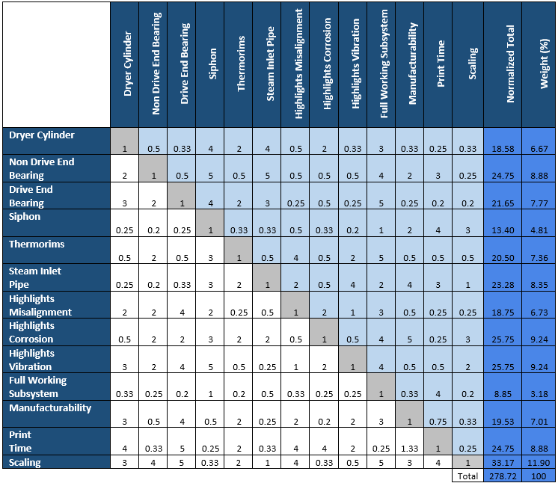

Appendix B: Inserting References
To assist you with listing and citing references in your reports, Microsoft Word includes a references tool. This tool allows for easy insertion of reference listings within the text as well as generating reference citations at the end of the report. This tool also reorders the reference listings and citations, even if you add or delete reference listings. As commonly done in engineering reports, this report’s format recommends an IEEE format, which calls for numbered listings in brackets to be placed within the text.
To insert a reference listing, click the “References” tab from the top ribbon. In the “Insert Citation” menu, select “Add New Source.” Both of these buttons are shown in Figure B-1. Upon clicking “Add New Source,” a window appears, prompting information about the source. Once you have inserted the information, a bracketed reference listing will appear with the number of the reference attributed to the source. This reference listing number corresponds to a reference citation number in the References section at the end of the report.

Figure B-1: The sequence of clicks to add a new source to a technical report. Move from “References” to “Insert Citation” to “Add New Source.”
Once you have completed the main text and appendices, insert a page break and add the References section. By clicking the “Bibliography” option, the references are automatically generated and formatted in the IEEE format. Figure B-2 shows the sequence of clicks to insert a References page. Note that because parentheses are used for so many purposes in engineering documents, such as for units or abbreviations, most engineering formats call for a references style that relies on bracketed reference listings similar to the IEEE format.
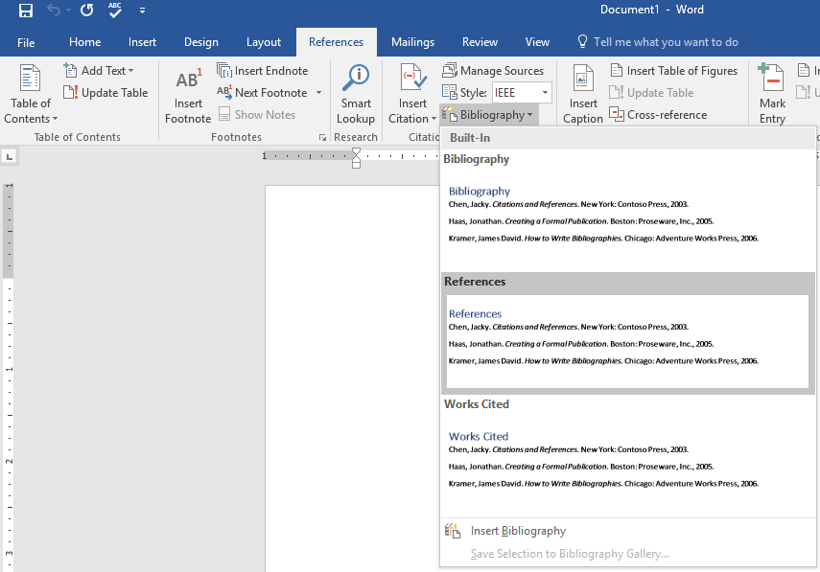
Figure B-2: The sequence of clicks to add a references section to a technical report.
If changes are made to the in-text citations in the text, be sure to “update” the references prior to completion of the report. As shown in Figure B-3, an update is performed by clicking the Reference Title and selecting update.

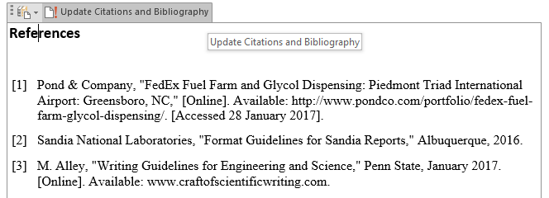
Figure B-3: The clicks for updating the References section of a technical report.
Because this appendix was included solely to help you with the formatting of the reference citations, please be sure to delete this appendix before submission of your team’s proposal. Also, please remember that each appendix as well as the References section are to begin on a new page.

References

[1] | Pond & Company, "FedEx Fuel Farm and Glycol Dispensing: Piedmont Triad International Airport: Greensboro, NC," [Online]. Available: http://www.pondco.com/portfolio/fedex-fuel-farm-glycol-dispensing/. [Accessed 28 January 2017].
[2] | Sandia National Laboratories, "Format Guidelines for Sandia Reports," Albuquerque, 2016.
[3] | Caddell, "Bulk Fuel Storage Facility: Raleigh-Durham Airport, NC," [Online]. Available: http://www.caddell.com/aviation/airport-infrastructure/bulk-fuel-storage-facility.aspx. [Accessed 28 January 2017].
[4] | M. Alley, "Writing Guidelines for Engineering and Science," Penn State, January 2017. [Online]. Available: www.craftofscientificwriting.com.
[5] | Y. Cengel and M. Boles, Thermodynamics: An Engineering Approach, New York: McGraw-Hill, 2014.
[6] | R. A. Perry and D. L. Siebers, "Rapid Reduction of Nitrogen Oxides from Diesel Exhaust Engines," Nature, vol. 324, no. 2, pp. 657-659, August 1986.
[7] | D. Cheng, Chemtronix XT Manometer [brochure], Asheville, N.C.: Chemtronix Corporation, 1974.
[8] | J. Frank, The Industrial Internet of Things: Predictive Maintenance in Advanced Manufacturing [presentation], University Park, PA: ME 340, Penn State, 2016.
[9] | IBM, Guide to Operations, Boca Raton, Florida: IBM Personal Computer Hardware Reference Library, 1984.
[10] | R. K. Lyon.United States of America Patent 3,900,554, August 1975.
[11] | R. Lee, Engineer at Apple Corporation [interview], 1987.
[12] | J. Mockery, "Cross-Section of a single stage radial centrifugal pump," May 2007. [Online]. Available: http://hu.wikipedia.org/wiki/F%C3%A1jl:CetriFugal_Pump.jpg. [Accessed October 2016].
[13] | "Plastic Explosives Blamed for Airline Disaster," The New York Times, pp. B-11, 3 January 1989.
[14] | ME 340 Teaching Team, Lab 6: Functional Decomposition and Analytic Hierarchy Process (AHP), University Park: Mechanical Engineering Department, Penn State, 2016.
[15] | M. Alley, The Craft of Scientific Writing, 4th ed., New York: Springer, 2018.
[16] | A. Kumar, N. Nace, J. Benton and F. Santilli, Proposal to Print a 3D-Model of a Paper Dryer Roller to Represent Bearing Failure, University Park, PA: ME 340, Penn State, 2016.
[17] | Neptuno Pumps, "Vertical Turbine Pump: Enclosed Shaft Assembly," 20 June 2012. [Online]. Available: https://www.youtube.com/watch?v=5v8rj3Pyvds.
[18] | M. Alley, The Craft of Scientific Presentations, New York: Springer-Verlag, 2013.

